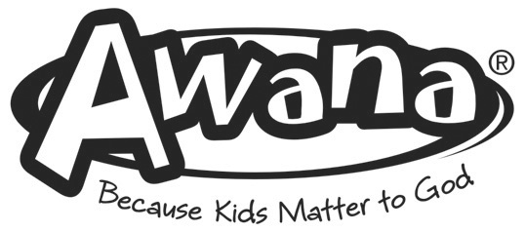

AWANA REGISTRATION 2021-2022

Trinity Hills Baptist Church

Please complete both sides of this form and sign. Please Print.
Family Last Name: |  | _____________________ | _____________________
Fathers Name |  | Mothers Name:
Address Street |  | City: Zip:
Phone: | Cell Father: | Cell Mother: | _____________________
E-mail: |  | Home Church:
If your home church is Trinity Hills Baptist Church, what ministry are you currently serving in?

Emergency Contact: Phone

Private Physician: Phone

Awana 2021-2022
-- MEDICAL RELEASE --

The Bearer, an authorized representative of Trinity Hills Baptist Church is hereby authorized and empowered at his discretion to request, authorize, and empower any licensed doctor of medicine to administer any medical treatment which such doctor at his sole discretion deems necessary or advisable for the medical care of my child (listed above) if I or my spouse cannot be located including, but not limited to, surgery, hospitalization, prescription of drugs and other medical treatment which such doctor shall determine to be necessary. I also authorize such doctor to retain the services of medical specialists, which such doctor deems necessary for the medical care of my child. I hereby agree to be responsible for all charges incurred in the treatment of my child, including but not limited to, ambulance fees, doctor fees, medicines and hospital charges. I hereby also agree to hold Trinity Hills Baptist Church and its representative(s) harmless in the exercise of the authorization given therein.

Signature of Parent:_________________________________________Today’s Date:____/_____/_____

PHOTO RELEASE
I, the undersigned, do hereby authorize Trinity Hills Baptist Church (the “church”) to use and publish photographs of my child or children, or in which my child or children may be included, in any church publication, including the church’s videos, websites, and promotional materials. I hereby release the church and its employees and agents from all claims and liability relating to said photographs. I understand that, if I should change my mind about this decision, I may contact the AWANA Commander.

Signature of Parent:_________________________________________Today’s Date:____/_____/_____

God can use you in AWANA! Please volunteer!

(Please check) Yes, I would like to consider being a volunteer in AWANA on Sunday. Please contact me.

(Please check) Yes,I would like to be considered for a partial scholarship. Scholarships are based on need.

PLEASE TURN OVER
Awana Registration -- Children Information
Please designate Club based on the following age classifications:
Cubbies – Age 3 by September 1st Sparks – Kindergarten / 1st / 2nd Grade
T&T – 3rd/4th/5th Grade Trek – 6th/7th/8th Grade Journey – 9th thru 12th Grade

*Please list allergies or medical condition we should be aware of. If child is on medication, please list.
Child’s Name First / Last | Date  of  Birth | Age | Grade in Fall 2021 | Club | Who is authorized to pick  up this child?  (For Cubbies & Sparks Only) | New To Awana (Y/N)
1) |  |  |  |  | Father Mother  Other____________________
Medical*:
2) |  |  |  |  | Father Mother  Other____________________
Medical*:
3) |  |  |  |  | Father Mother  Other____________________
Medical*:
4) |  |  |  |  | Father Mother  Other____________________
Medical*:
5) |  |  |  |  | Father Mother  Other____________________
Medical*:
6) |  |  |  |  | Father Mother  Other____________________
Medical*:
7) |  |  |  |  | Father Mother  Other____________________
Medical*:
8) |  |  |  |  | Father Mother  Other____________________
Medical*:
9) |  |  |  |  | Father Mother  Other____________________
Medical*:
10) |  |  |  |  | Father Mother  Other____________________
Medical*:
11) |  |  |  |  | Father Mother  Other____________________
Medical*:
12) |  |  |  |  | Father Mother  Other____________________
Medical*:
Office Use Only Amount Paid______________________Check#__________Cash_________

Date Received____________________________By_______________________

